|  |
| --- |
| logo.png |
| Tire Management System  User Manual |
| |  |  |  | | --- | --- | --- | | Jason Ricardo | 4/20/15 | Cen 3073 | |

Table of Contents

[System Requirements 2](#_Toc417476873)

[What is Tire Management System 2](#_Toc417476874)

[How to Install 2](#_Toc417476875)

[Main Screen: 3](#_Toc417476876)

[Options: 4](#_Toc417476877)

[Search By Customer: 5](#_Toc417476878)

[Adding a Customer: 6](#_Toc417476879)

[Generating an Invoice: 7](#_Toc417476880)

[Search by Date: 10](#_Toc417476881)

Introduction

## System Requirements

|  |  |
| --- | --- |
| Windows | |
| Operating System | [Windows](https://en.wikipedia.org/wiki/Microsoft_Windows) 8.1 64 Bit, Windows 8 64 Bit, Windows 7 64 Bit Service Pack 1, Windows Vista 64 Bit Service Pack 2 |
| CPU | [Core 2 Duo](https://en.wikipedia.org/wiki/Core_2_Duo) or [Athlon X2](https://en.wikipedia.org/wiki/Athlon_X2) at 2.4 GHz |
| Memory | 2 GB of RAM or more |
| Hard drive | At least 250MB of free space |

|  |  |
| --- | --- |
| Mac | |
| Operating System | Mac OS X 10.2 or later |
| CPU | [Core 2 Duo](https://en.wikipedia.org/wiki/Core_2_Duo) at 2.4 GHz or superior |
| Memory | 2 GB of RAM or more |
| Hard drive | At least 250MB of free space |

## What is Tire Management System

Tire Management System is a program for used tire shops who need some management software. The program keeps inventory of the items owned by the business owners. The software will keep customer information for future purchases. Once the customer comes back the software can pull up there history and create an invoice.

## How to Install

First install java environment if not installed already. Then download the jar file to your computer. Double click the following icon

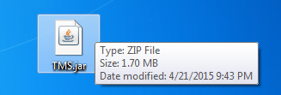

Java runtime environment will now launch your application.

How To Use

## Main Screen:

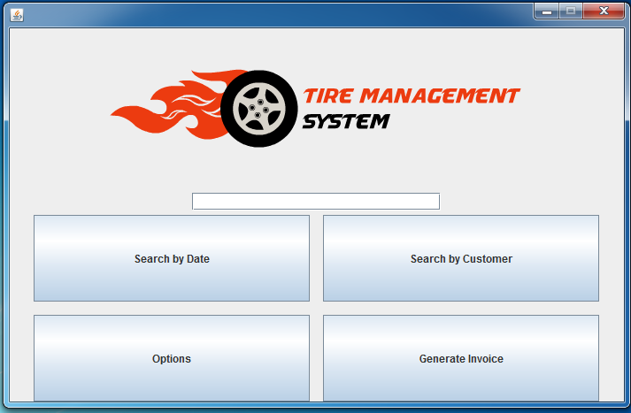

The search bar can be used to find a customer or a date. Please type in the information and press search by customer or by Date

## Options:

The options button will lead to changing basic information of the store and adding more inventory to the system.

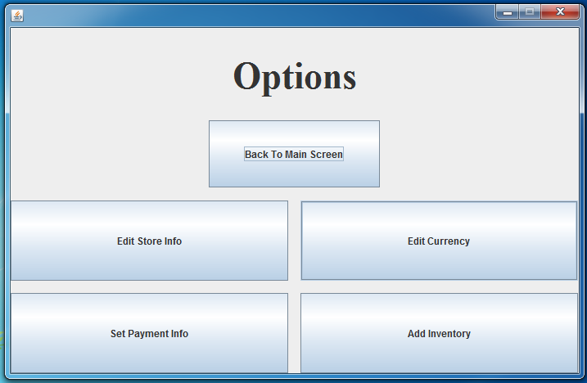

Store information lets the user establish the basics for the business including the hours of operations and days of work. It will retain this information in the database

Let’s the user choose their currency options

Returns to Main Screen

The information like credit card information can be stored so a will known customer can make orders over the phone and have them processed.

The business inventory will be within add inventory. The user can add new inventory or view the current inventory in stock.

## Search By Customer:

The search by customer will populate a list of customers that are already in the system. If the list is empty and it’s the first time using the software you can choose to add a new customer. If you would like to add more customers just use the add customer button.

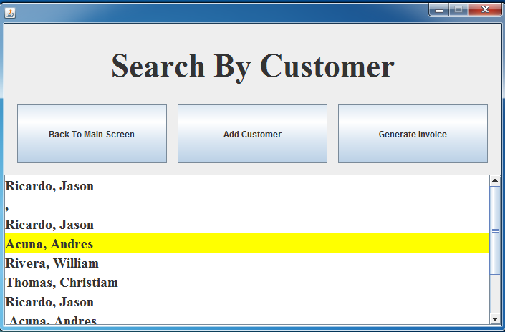

Button to add new customer

With a customer selected we can now generate an invoice

Yellow indicates a customer is selected.

## Adding a Customer:

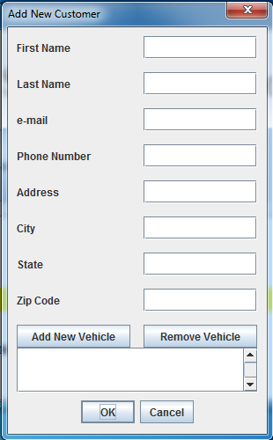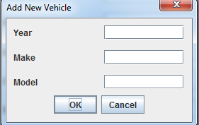

When “Add New Vehicle” button is pressed the screen below appears. Once the user hits okay it will store the vehicle information under the customer profile

When adding a new customer please input as much information as possible because this information will be automatically generated on the invoice when an invoice is created. If the user adds a vehicle they will have the option to place the vehicle into an invoice.

## Generating an Invoice:

Once a customer is selected we can choose to create an invoice using the “Generate Invoice button”

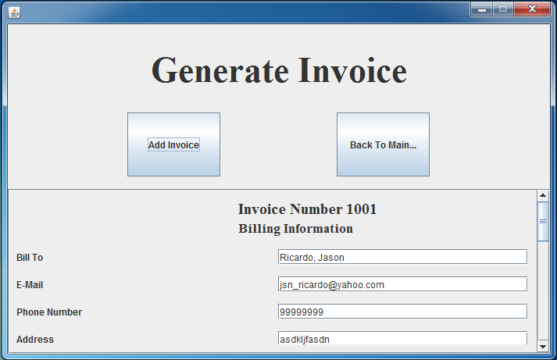

As we can see above the customer information is automatically added into the invoice generated.

Adds Invoice to the system

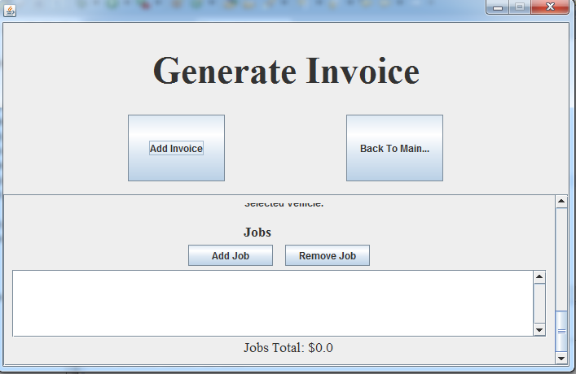

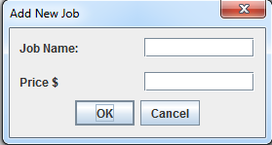

We can then add at the bottom of the invoice window the jobs performed for the customer. We can then press okay and choose to add another service that was provided to the customer on the date of service. After all the services are entered it would like the following screen.

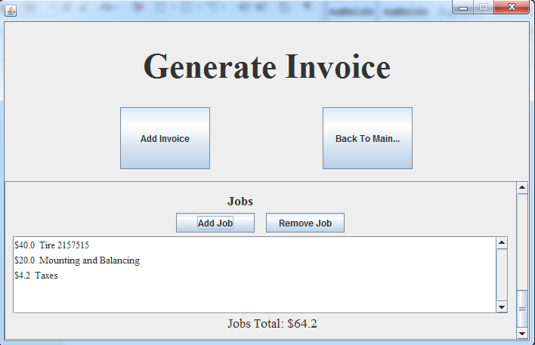

This is the final screen to generate the invoice for the customer. We can click add invoice and this will be saved by the customer name.

## Search by Date:

The search by date is very similar to the Search by customer the only big difference is that the invoices are generated by date. We can choose to find the earliest day or oldest day and edit the invoice or recheck it. Finally we can decide to generate an all new invoice.

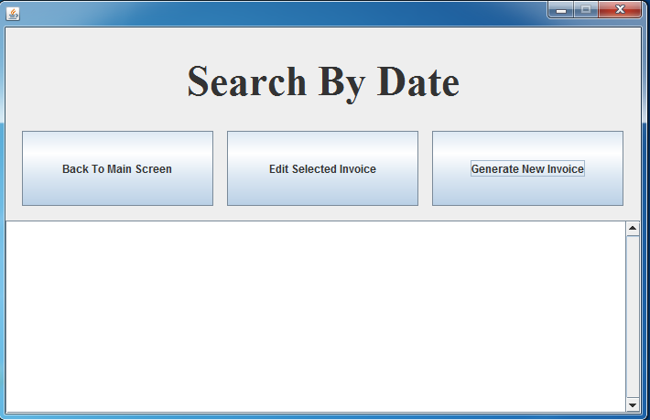

## In conclusion:

Thank you for reading Tire Management System User manual we hope this has been helpful in learning our system. If there is any questions feel free to contact the development team for customization and support at jricardo1528@eagle.fgcu.edu.

C:\Users\James Ronald Green\Pictures\TMS_Logo3.png

“We strive for customer satisfaction”